**Chirag H M – 6373750(superset id)**

Exercise 1: Mocking and Stubbing

**cenario:**

You need to test a service that depends on an external API. Use **Mockito** to mock the external API and stub its methods.

**Steps:**

1. Create a mock object for the external API.
2. Stub the methods to return predefined values.
3. Write a test case that uses the mock object.

**Add the following dependencies to the pom.xml file**

<dependencies>

<!-- JUnit 5 -->

<dependency>

<groupId>org.junit.jupiter</groupId>

<artifactId>junit-jupiter-api</artifactId>

<version>5.10.0</version>

<scope>test</scope>

</dependency>

<dependency>

<groupId>org.junit.jupiter</groupId>

<artifactId>junit-jupiter-engine</artifactId>

<version>5.10.0</version>

<scope>test</scope>

</dependency>

<!-- Mockito -->

<dependency>

<groupId>org.mockito</groupId>

<artifactId>mockito-core</artifactId>

<version>5.11.0</version>

<scope>test</scope>

</dependency>

</dependencies>

**Create Classes as below:**

ExternalApi.java

package com.example.mockito;

public interface ExternalApi {

String getData();

}

MyService.java

package com.example.mockito;

public class MyService {

private ExternalApi externalApi;

public MyService(ExternalApi externalApi) {

this.externalApi = externalApi;

}

public String fetchData() {

return externalApi.getData();

}

}

MyServiceTest.java

package com.example.mockito;

import org.junit.jupiter.api.Test;

import static org.mockito.Mockito.*;

import static org.junit.jupiter.api.Assertions.*;

public class MyServiceTest {

*@Test*

public void testExternalApi() {

ExternalApi mockApi = *mock*(ExternalApi.class);

*when*(mockApi.getData()).thenReturn("Mock Data");

MyService service = new MyService(mockApi);

String result = service.fetchData();

*assertEquals*("Mock Data", result);

}

}

Output:

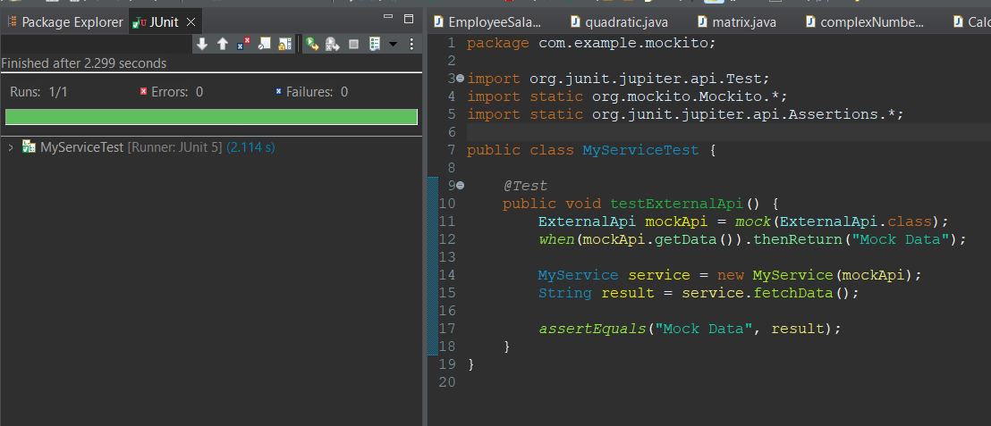

**Exercise 2:Verifying interactions**

### Goal:

To **verify** that a method (getData()) is called on a **mocked object** (ExternalApi) with **specific arguments (if any)**.

#### Define the classes

**ExternalApi.java**

package com.example.mockito;

public class ExternalApi {

public void getData() {

System.***out***.println("Fetching data from external API...");

}

}

MyService.java

package com.example.mockito;

public class MyService {

private ExternalApi externalApi;

public MyService(ExternalApi externalApi) {

this.externalApi = externalApi;

}

public void fetchData() {

externalApi.getData();

}

}

MyServiceTest.java

package com.example.mockito;

import org.junit.jupiter.api.Test;

import static org.mockito.Mockito.*;

public class MyServiceTest {

*@Test*

public void testVerifyInteraction() {

// Step 1: Create mock

ExternalApi mockApi = *mock*(ExternalApi.class);

// Step 2: Inject mock into service

MyService service = new MyService(mockApi);

// Step 3: Call method

service.fetchData();

// Step 4: Verify interaction

*verify*(mockApi).getData();

}

}

**Output:**

